Ginger Geoffrey - Too Old to Die Young
Singer Songwriter

Ginger Geoffrey's Too Old to Die Young solo band kicks and strums its way through original songs and an eclectic mix of adapted indie pop and rock classics. With guitar, vocals, foot drum, performances are a cacophony of spinning plates, head tapping and tummy rubbing shenanigans with absolutely no prerecords or looping pedals. A 100% bare-bones live performance delivering a rich energetic scrumptious tub-thumping sound. What on earth could go wrong?

Gingers own writing is influenced by the intense rhythmic guitar style of Richie Havens and writing styles of Mark Nevin, Adam Duritz and Paul Heaton, (Fairground Attraction, Counting Crows and The Beautiful South); Ginger writes predominantly story-driven songs drawn from personal and observed experiences. From the resilience of ‘Take what you want’ and ‘Get out of here’, optimism of ‘This heart of mine’, ‘Rendezvous’ and ‘First sight’; despair, lust and regret of ‘Wake-up’, ‘Wanna love you’ and ‘Gone’ these tracks are a journey through the highs and lows of affairs of the heart.

Background Biography:
The son of a dustman and seamstress, and raised on a West London, council estate. After a brief spell in Cornwall, Ginger has laid his hat in Staffordshire England for nearly four decades. A self-taught musician, Ginger describes his earliest memory of playing guitar:

“In the mid-seventies an uncle of mine spent some time at Her Majesties pleasure so my parents were looking after some of stuff in our flat, this included two guitars, one a beaten-up old acoustic, the other a rather dazzling Honda electric guitar. I was given explicit instructions not to touch any of it. However I discovered early Sunday mornings a TV show on ‘how to play guitar’ and being as how there were a couple in the flat I thought I just had to. While my folks were asleep, I’d take the battered old guitar, (The Honda looked far too intimidating) and I’d sit cross legged, really close-up to our black and white telly and try and copy what I saw. I never got caught, and as I recall I did learn the one fingered ‘G’ and ‘C’ chords.”

Contact Information:
Email: Dr.Jim.Davis@Mac.Com
Tel: +44 (0) 7941 545664

Useful links:
Artist Website:  http://www.gingergeoffrey.uk | Artist Instagram:  https://www.instagram.com/gingergeoffrey.uk/
Artist Facebook Page:  https://www.facebook.com/GingerGeoffreyUK/ | Artist Twitter Feed:  https://twitter.com/geoffrey_ginger
Artist Youtube:  https://tinyurl.com/Gg-YouTubeChannel | Sound Cloud:  http://soundcloud.com/bashandstrum
Spotify - Bash and Strum - Rendezvous (Album):  https://open.spotify.com/artist/6aWcSaJlq6XWbL0zNat9Kt | iTunes - Bash and Strum - Rendezvous (Album):  https://itunes.apple.com/gb/album/id914050070

Hi-res images available for download via the links provided below:
 | 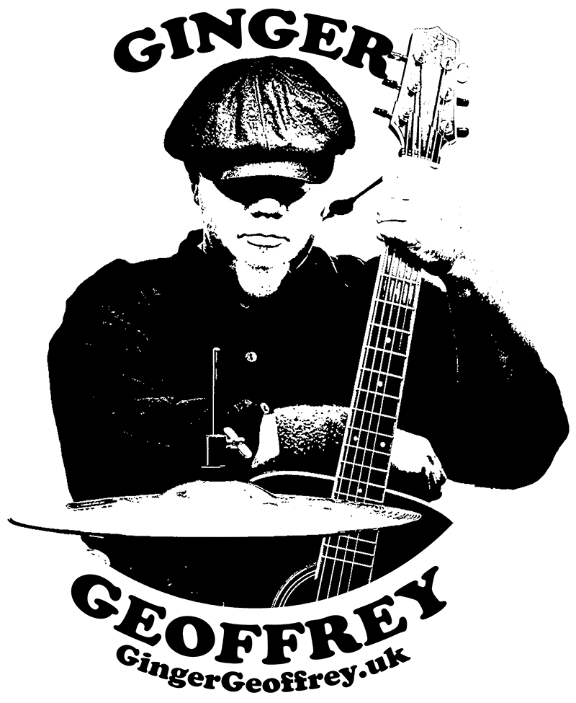
https://www.dropbox.com/s/jkspq1mfn7ns57b/GingerG_01b.jpg?dl=0  JPEG Image File 2.4MB | https://www.dropbox.com/s/3drvg9tbhdaphq5/GG-Silhouette.png?dl=0  JPEG Image File 1.4MB

